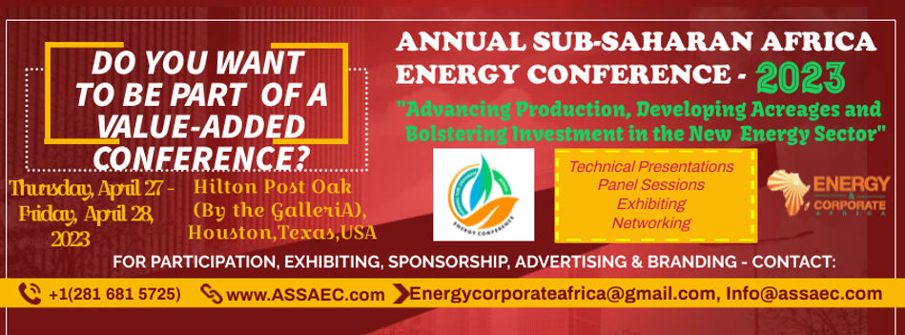

SECURE YOUR SPONSORSHIP EARLY! SPONSORSHIP OPPORTUNITIES
Exceptional opportunity to ENHANCE YOUR COMPANY PROFILE & put your brand in front of key industry leaders!

Yes! I am interested to sponsor 2023 Annual Sub-Saharan African Energy Conference
Please Select Sponsorship Category Below:
CHIEF HOST/DIAMOND SPONSORSHIP = $50,000
PLATINUM SPONSORSHIP = $30,000
HEAVY GOLD SPONSORSHIP = $25,000
GOLD SPONSORSHIP = $20,000
HEAVY SILVER SPONSORHIP = $15,000
SILVER SPONSORSHIP = $10,000
HEAVY BRONZE = $7,000
BRONZE SPONSORSHIP = $5,000
IT/AV SPONSORSHIP = $6,000
SPONSOR A PANEL SESSION = $8,000
PAYMENT INFORMATION:

NAME OF COMPANY:_____________________________________________________
ADDRESS:_________________________________________________________________
CONTACT PERSON:_________________________________________________________
POSITION IN COMPANY:___________________________________________________
EMAI:______________________________________ TEL:__________________________
SIGNATURE:_______________________________ DATE:________________________
By signing this form the company and its authorized representative has agreed to make payment as indicated. This signed form is now a contract or agreement between Energy & Corporate Africa producers of Annual Sub-Saharan Africa Energy Conference and the interested company.
Kindly return this completed form to Energycorporateafrica@gmail.com. Subject is: SPONSORSHIP
THANK YOU FOR CHOOSING OUR CONFERENCE!

